Open Outdoor Visual Design Guide
Whole app design proposal
Revised 3 October 2026
Give the map more space and each task one clear next action. Keep the existing forest, linen and sage palette; replace repeated introductions and stacked cards with compact tools and an expandable field journal.
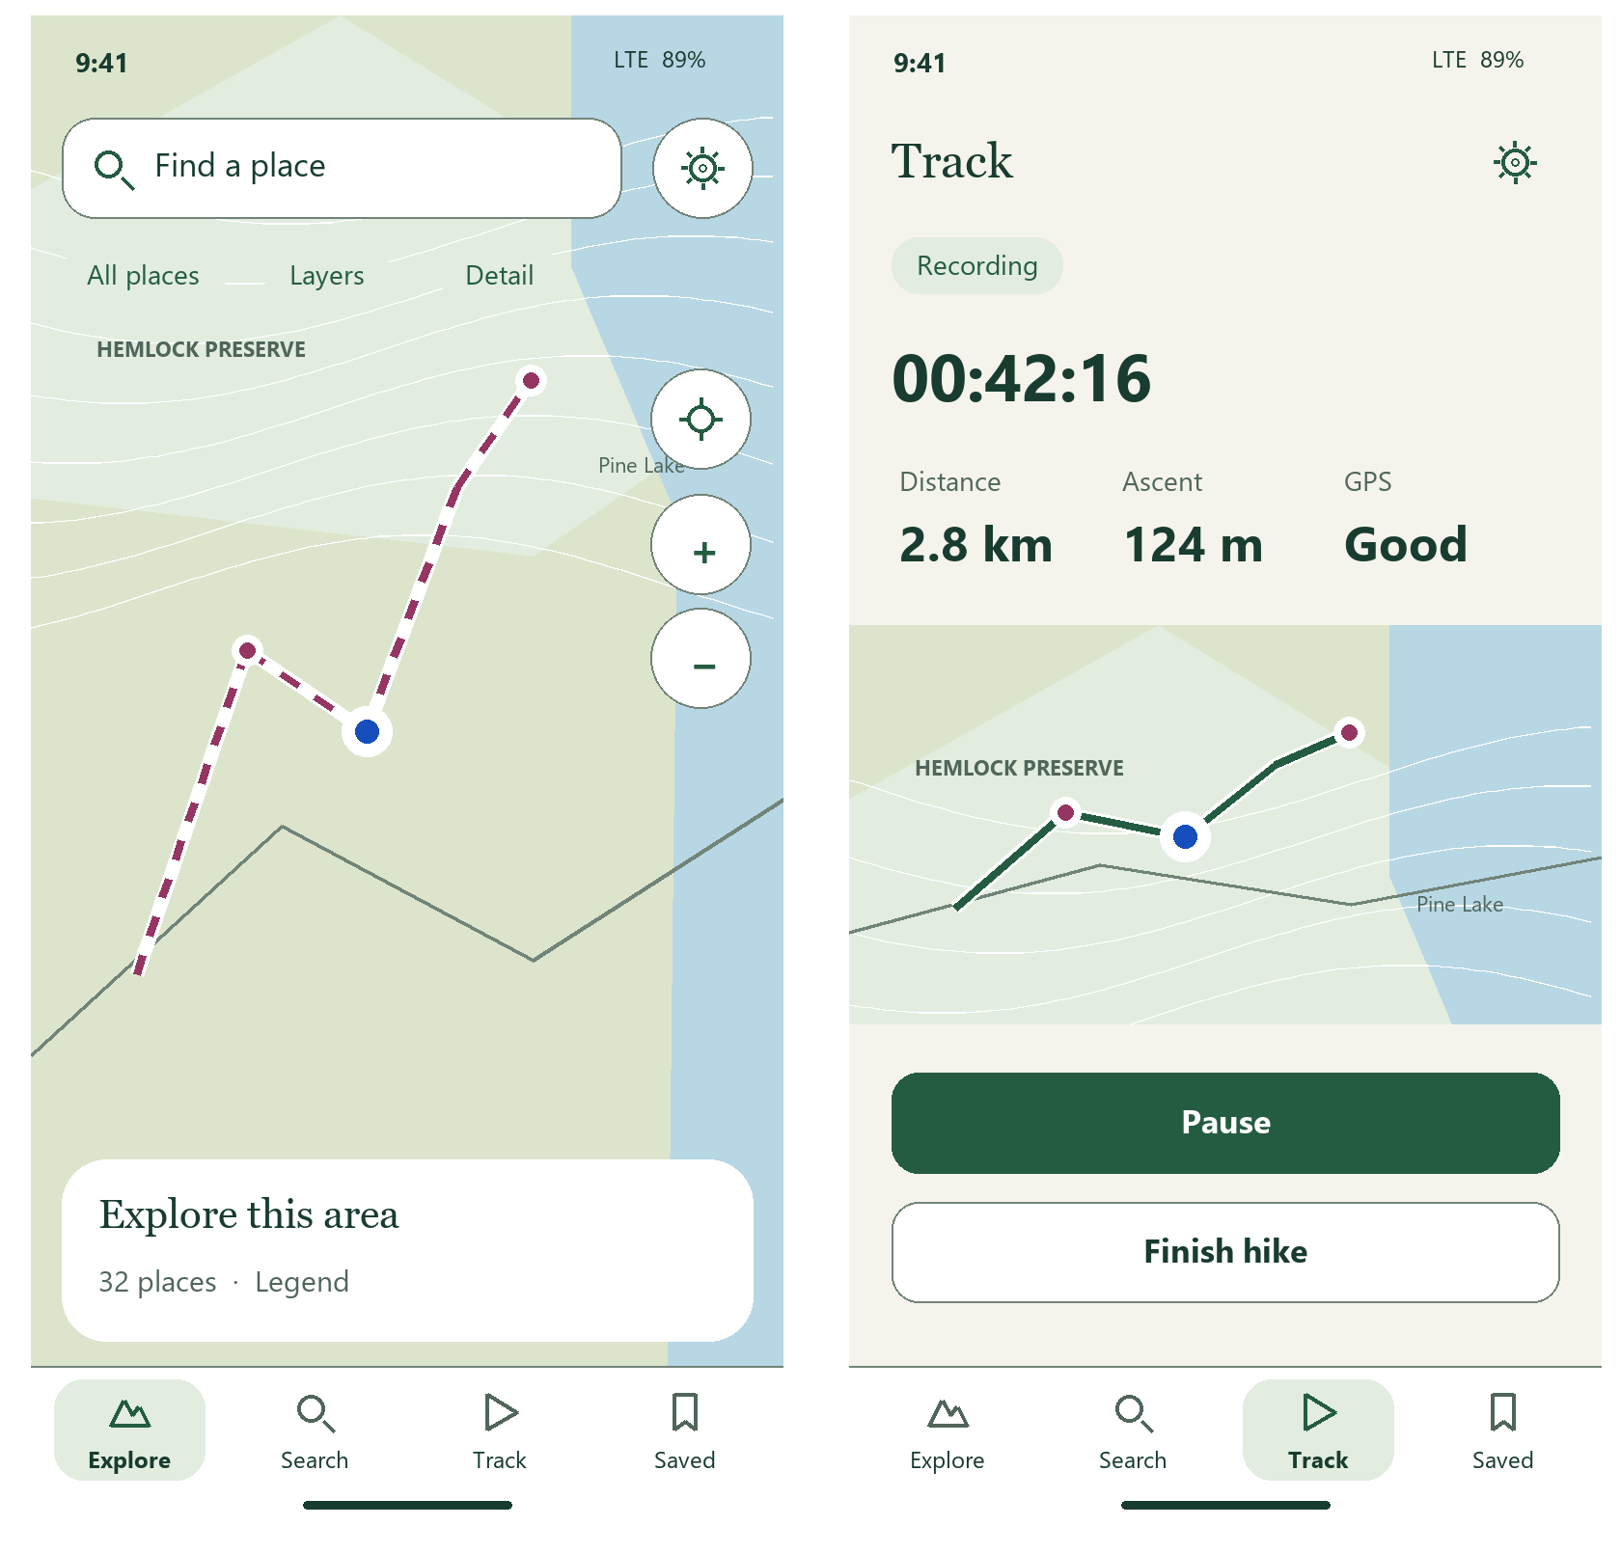
Proposed Explore and active recording. All maps, names and values in the concepts are illustrative.
This revision extends the original guide across the current app. Screens are proposals for a later implementation; no app code is changed.

Current screens and design changes
The six supplied captures are synthetic browser references. The two Explore phone captures duplicate the same view; native code provides the inventory of additional workflows.
Explore  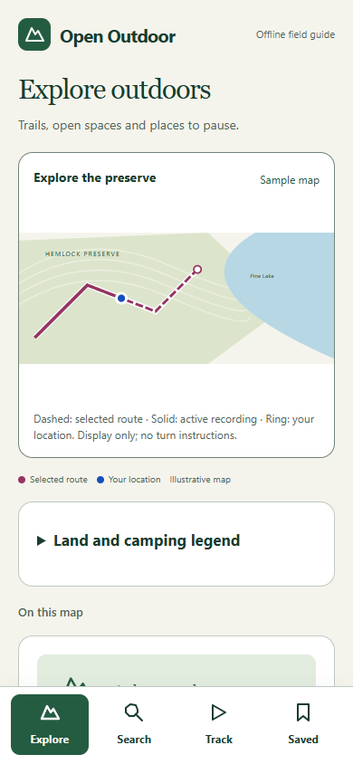 | Search  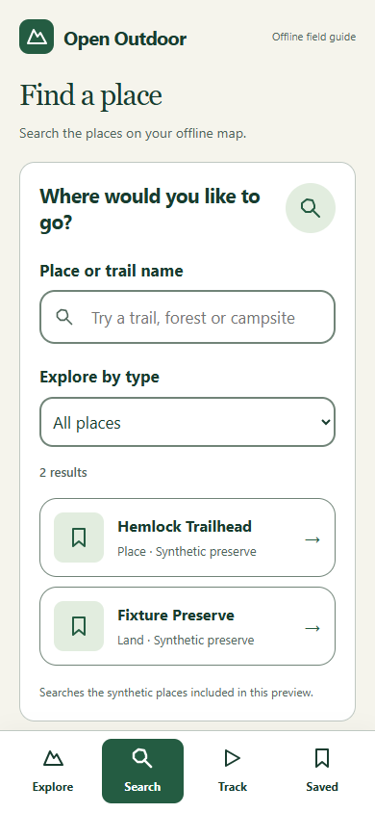 | Track  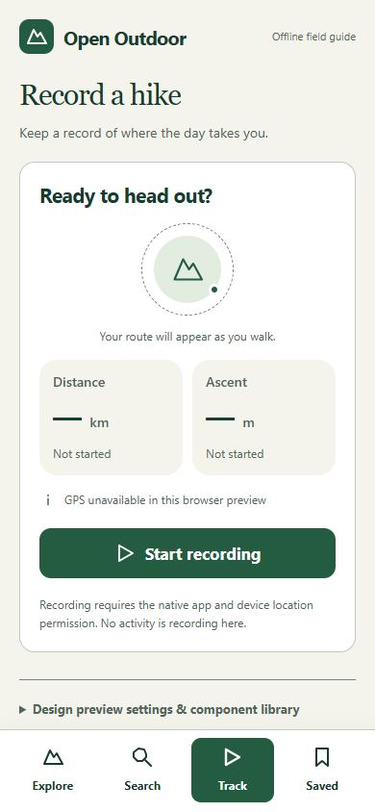 | Saved  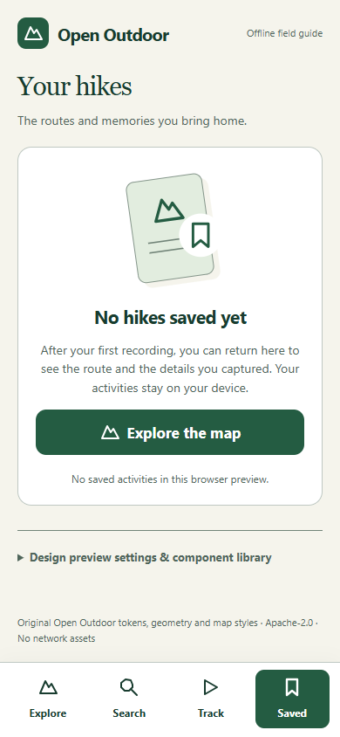
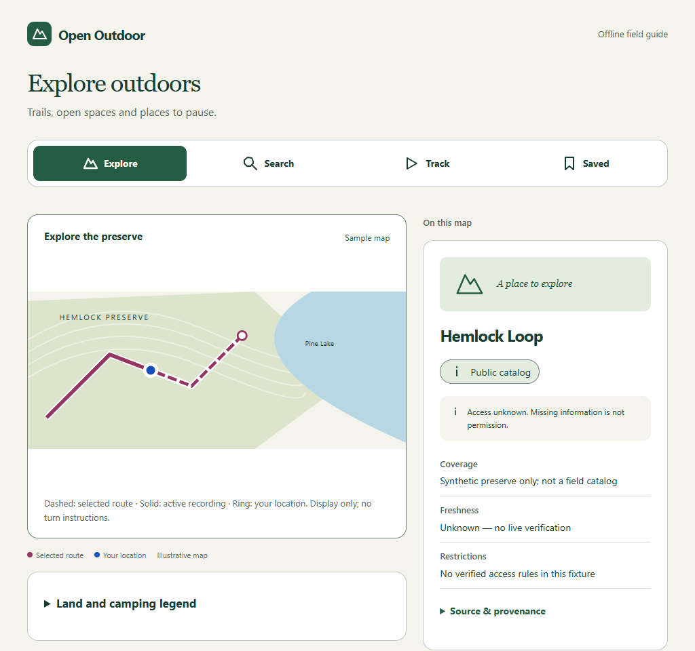
Current desktop reference. Native screenshots are not available in the supplied set.
Retain the palette, original mountain identity and four labeled tabs. Reduce large introductions, card borders, routine status paragraphs and duplicate action labels. Keep source warnings visible when they affect a decision.

Visual language and tokens
Use the existing palette without adding a new brand color. Let cartography, type and spacing create the change in character.
Role | Existing color | Proposed use
Canvas | #F5F4EC | Linen list pages and document surfaces
Surface | #FFFFFF | Sheets, tool controls and navigation
Text and action | #183C2F / #245C42 | Names, active tabs and one primary action
Selected and muted | #E2EDDF / #50665B | Selected rows and secondary metadata
Edge | #718478 | Controls, dividers and focus boundaries
Map | #DCE5CC / #B7D7E5 | Land and water
Route and location | #943562 / #164FBC | Planned path and position
Caution and danger | #79520B / #9D292C | Warnings and destructive actions
Success and focus | #256044 / #8645A0 | Completion and keyboard focus

Type and shape
Keep a moderate serif for page and place names. Use the platform sans serif for controls, values and body text. Retain 14 / 17 / 23 / 34 point tokens; reserve 34 for recording values, not routine introductions. Use 4 / 8 / 12 / 16 / 24 / 32 spacing, 14 point controls and 22 point cards. Proposed map sheets use 26 point top corners.

Component changes
Flat rows replace repeated bordered cards. A compact selected pill replaces the large filled navigation tile. Use one raised sheet over the map, a clear drag handle and a labeled Details action. Buttons retain 52 point targets; information pills become 52 point controls when interactive.
Map meaning stays consistent: dashed planned path, solid recorded path, ringed location. Color always has a text or shape companion. Mark clusters with counts and open their actual center; show selected places at their stored coordinates.

Screen structure and complete app map
Keep Explore, Search, Track and Saved in a persistent bottom row. Settings opens from the header; returning restores the prior tab, map position and query.
Area | Primary surfaces | Secondary surfaces
Explore | Map overview → place preview → full details | Layers, marker detail, legend, source evidence, directions
Places and trails | Place note / check-in; mapped route | Elevation sample, units, planned / recorded comparison
Search | Query → results → selected result | Category picker, no matches, coverage unavailable
Track | Ready → permission → recording → paused | Modes, finish / save, interrupted recovery, discard confirmation
Saved | Hikes / Places → activity or note | Recorded profile, unavailable reference route, return to recording
Settings | Maps, Appearance, Recording, About, Advanced | Bundled inventory, public packages, private imports, sources
Maps | Package details → coverage / visibility | Files install, GeoJSON review, rollback, remove / reset
Laptop | Discovery / QR / manual → catalog | Fingerprint approval, update selection, transfer / verify, revoke trust
System and failure | Permission prompts, app startup error | Storage, checkpoint, import, integrity and provisioning failures

Interaction rules
A place sheet has peek, reading and expanded positions. Details and Close provide button alternatives to dragging. Open directions through installed map apps. Settings never interrupts a recording; a slim recording return control remains visible in other tabs.
Draw navigation to the screen edge; pad its controls above the home indicator. Main content and pinned actions must end above that row. Opening the keyboard keeps Search and note actions reachable; text expansion can turn a sheet into a scrolling page.

Explore and place preview
Make the map the main surface. Search, layer controls and recentering float above it; selected details enter from the bottom.
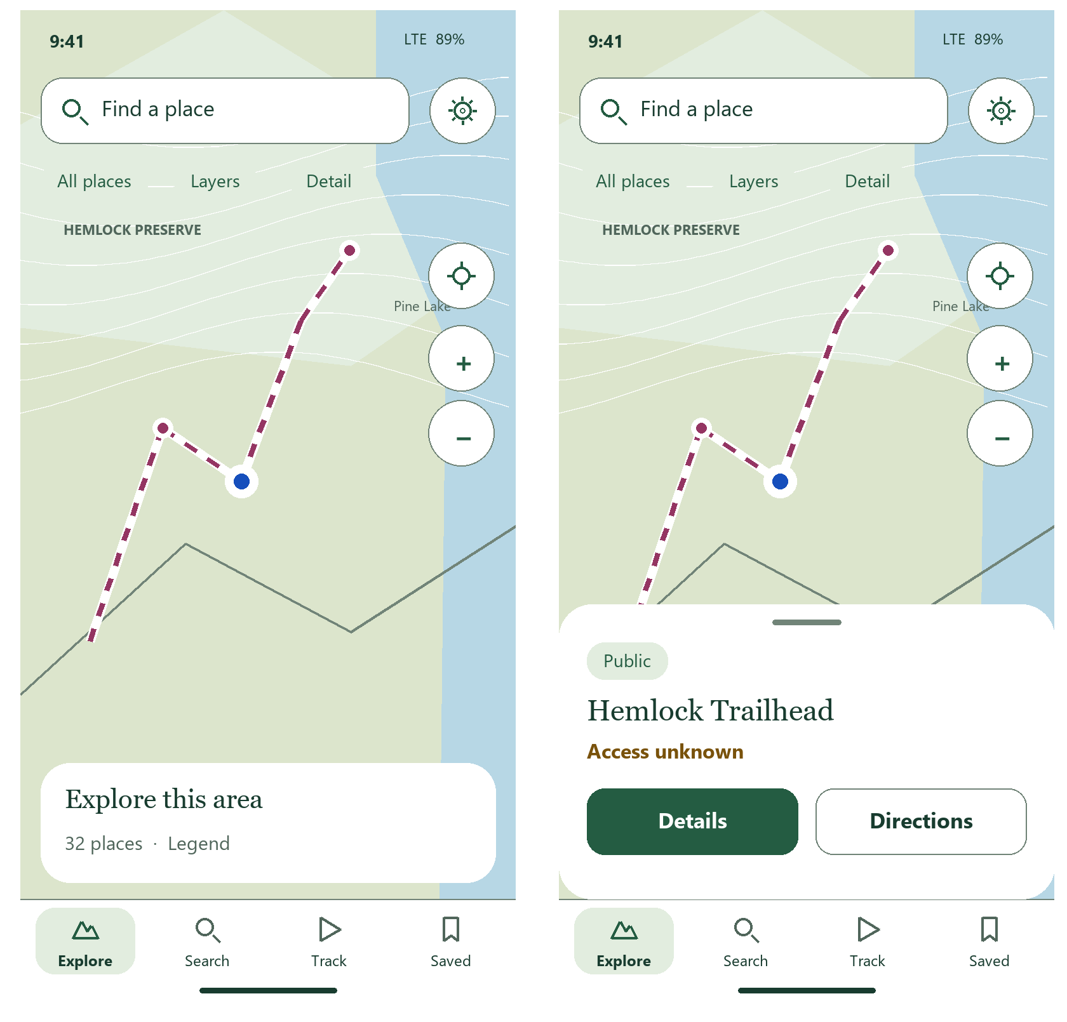
Left: no selection. Right: selected place in the peek sheet.
Tap a cluster to zoom into its center. Layer visibility and category choices also apply to search. Legend and marker detail open short sheets; avoid permanent explanation blocks.

Place details and private notes
Keep the place name, origin and relevant access warning visible. Source metadata expands only when requested.
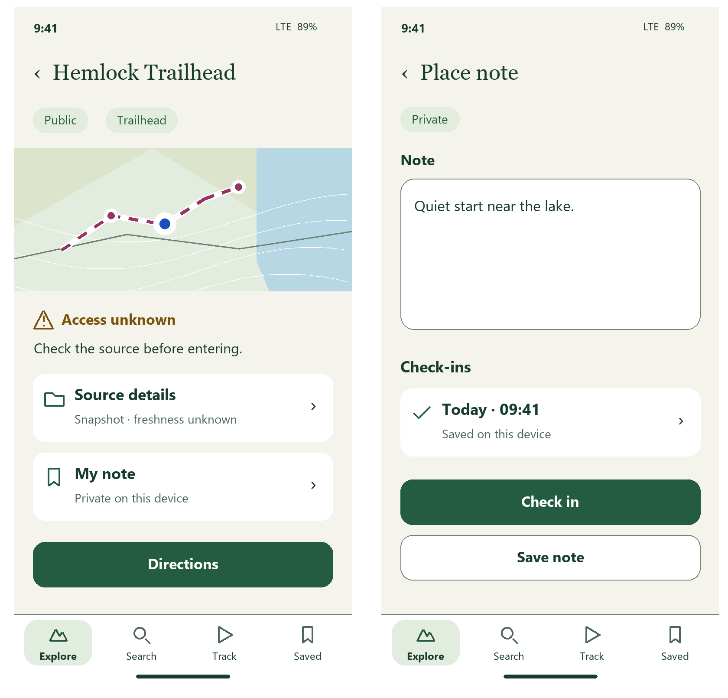
Left: place details. Right: local note and check-ins.
Directions opens a system chooser. Check in saves the current note with a timestamp; Save note adds no check-in. A private note does not change the catalog record or publish anything.

Mapped trails and directions
Lead with the path, distance and elevation evidence. Record this hike enters the existing recorder with the mapped plan attached.
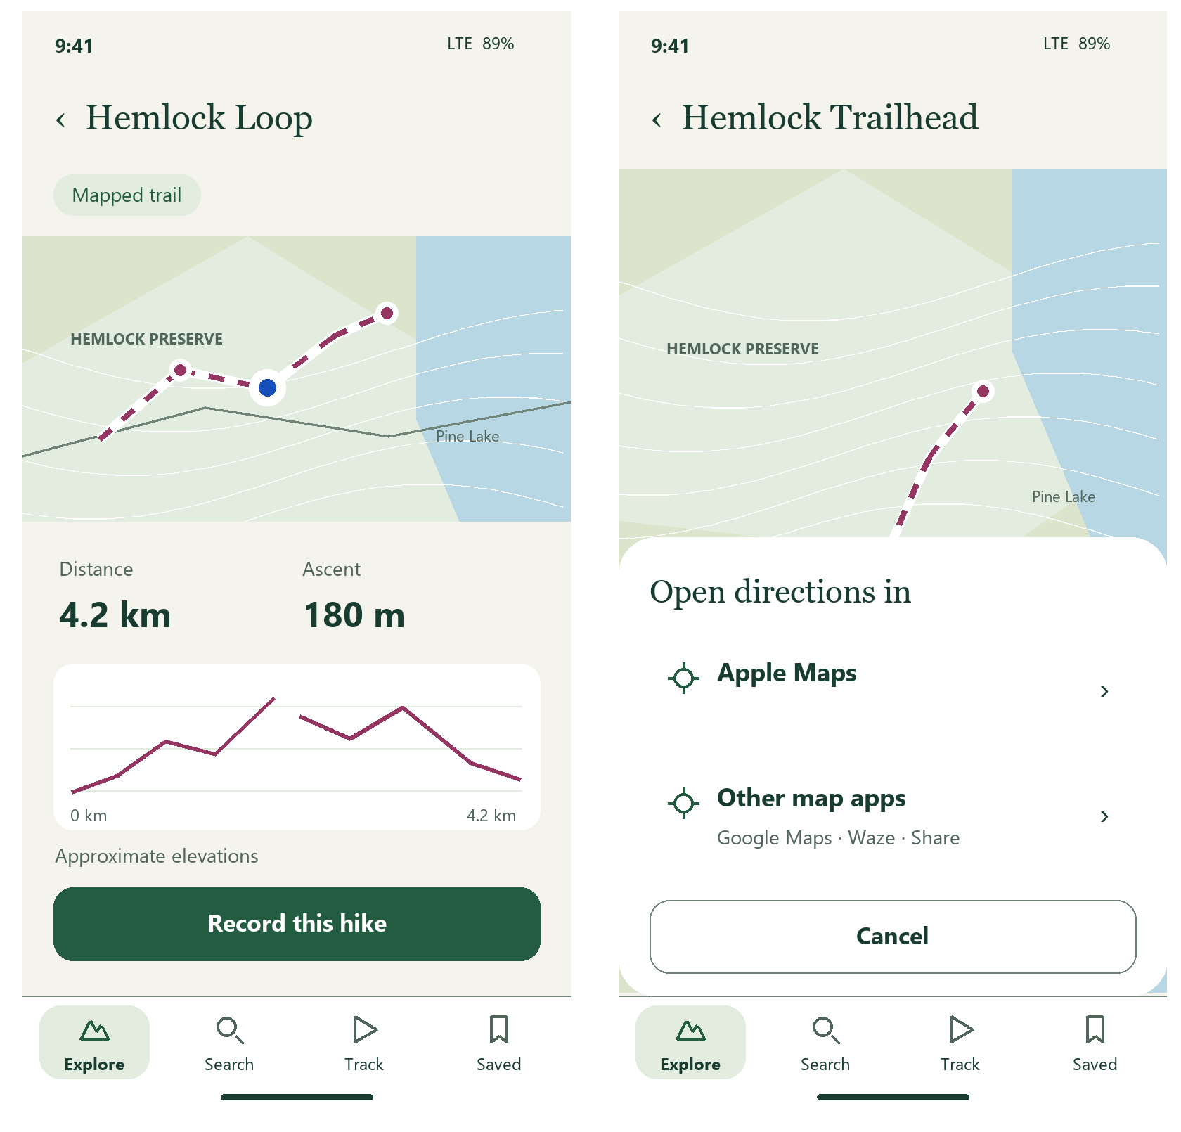
Left: mapped route and elevation profile. Right: directions chooser.
Inspecting the chart marks the matching point on the map. Missing elevation stays unknown. Units remain switchable. The directions handoff sends the destination or mapped start; external apps own navigation.

Search and category filters
A single search field and compact category controls replace the repeated query introduction. Keep result names and origin easy to scan.
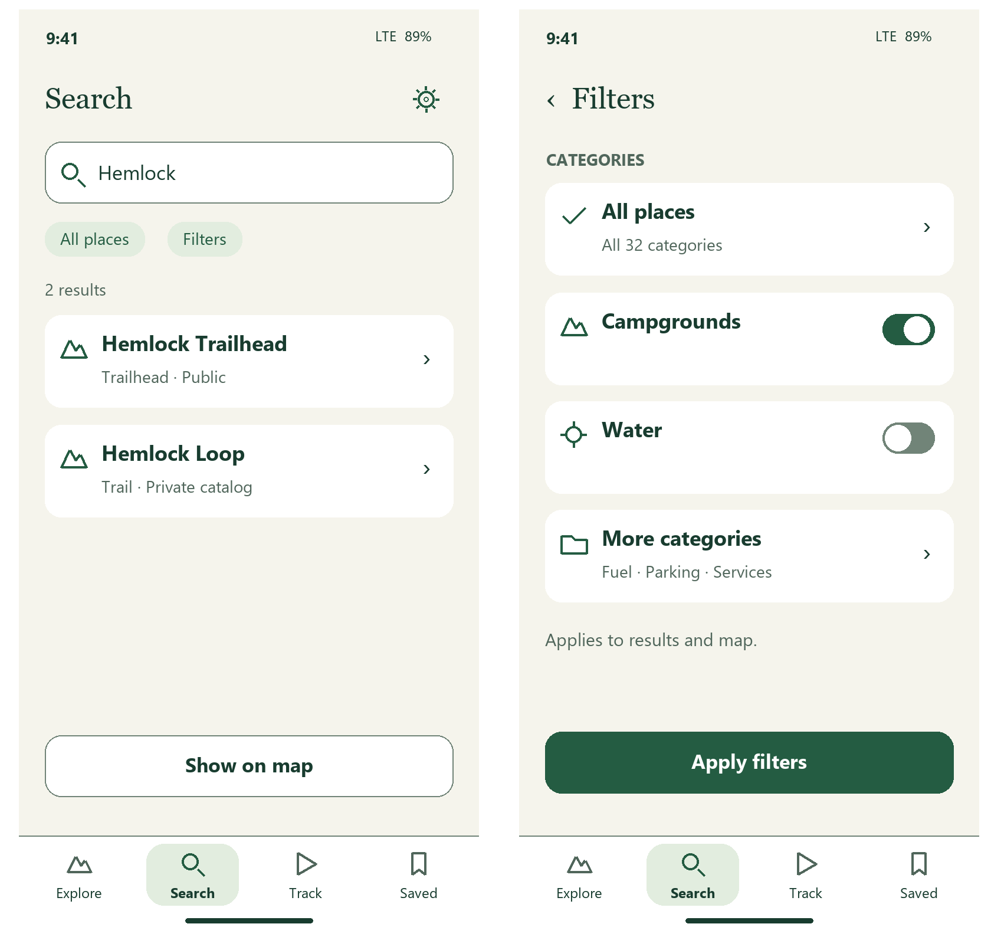
Left: populated query. Right: category sheet.
Keep query and filters on return. Categories include all existing iOverlander types with their current icons and colors. Apply affects list and map together; use All places as the clear reset.

Recording readiness and active capture
Use a small route preview and large time value. Distance, ascent and GPS share one quiet metric row.
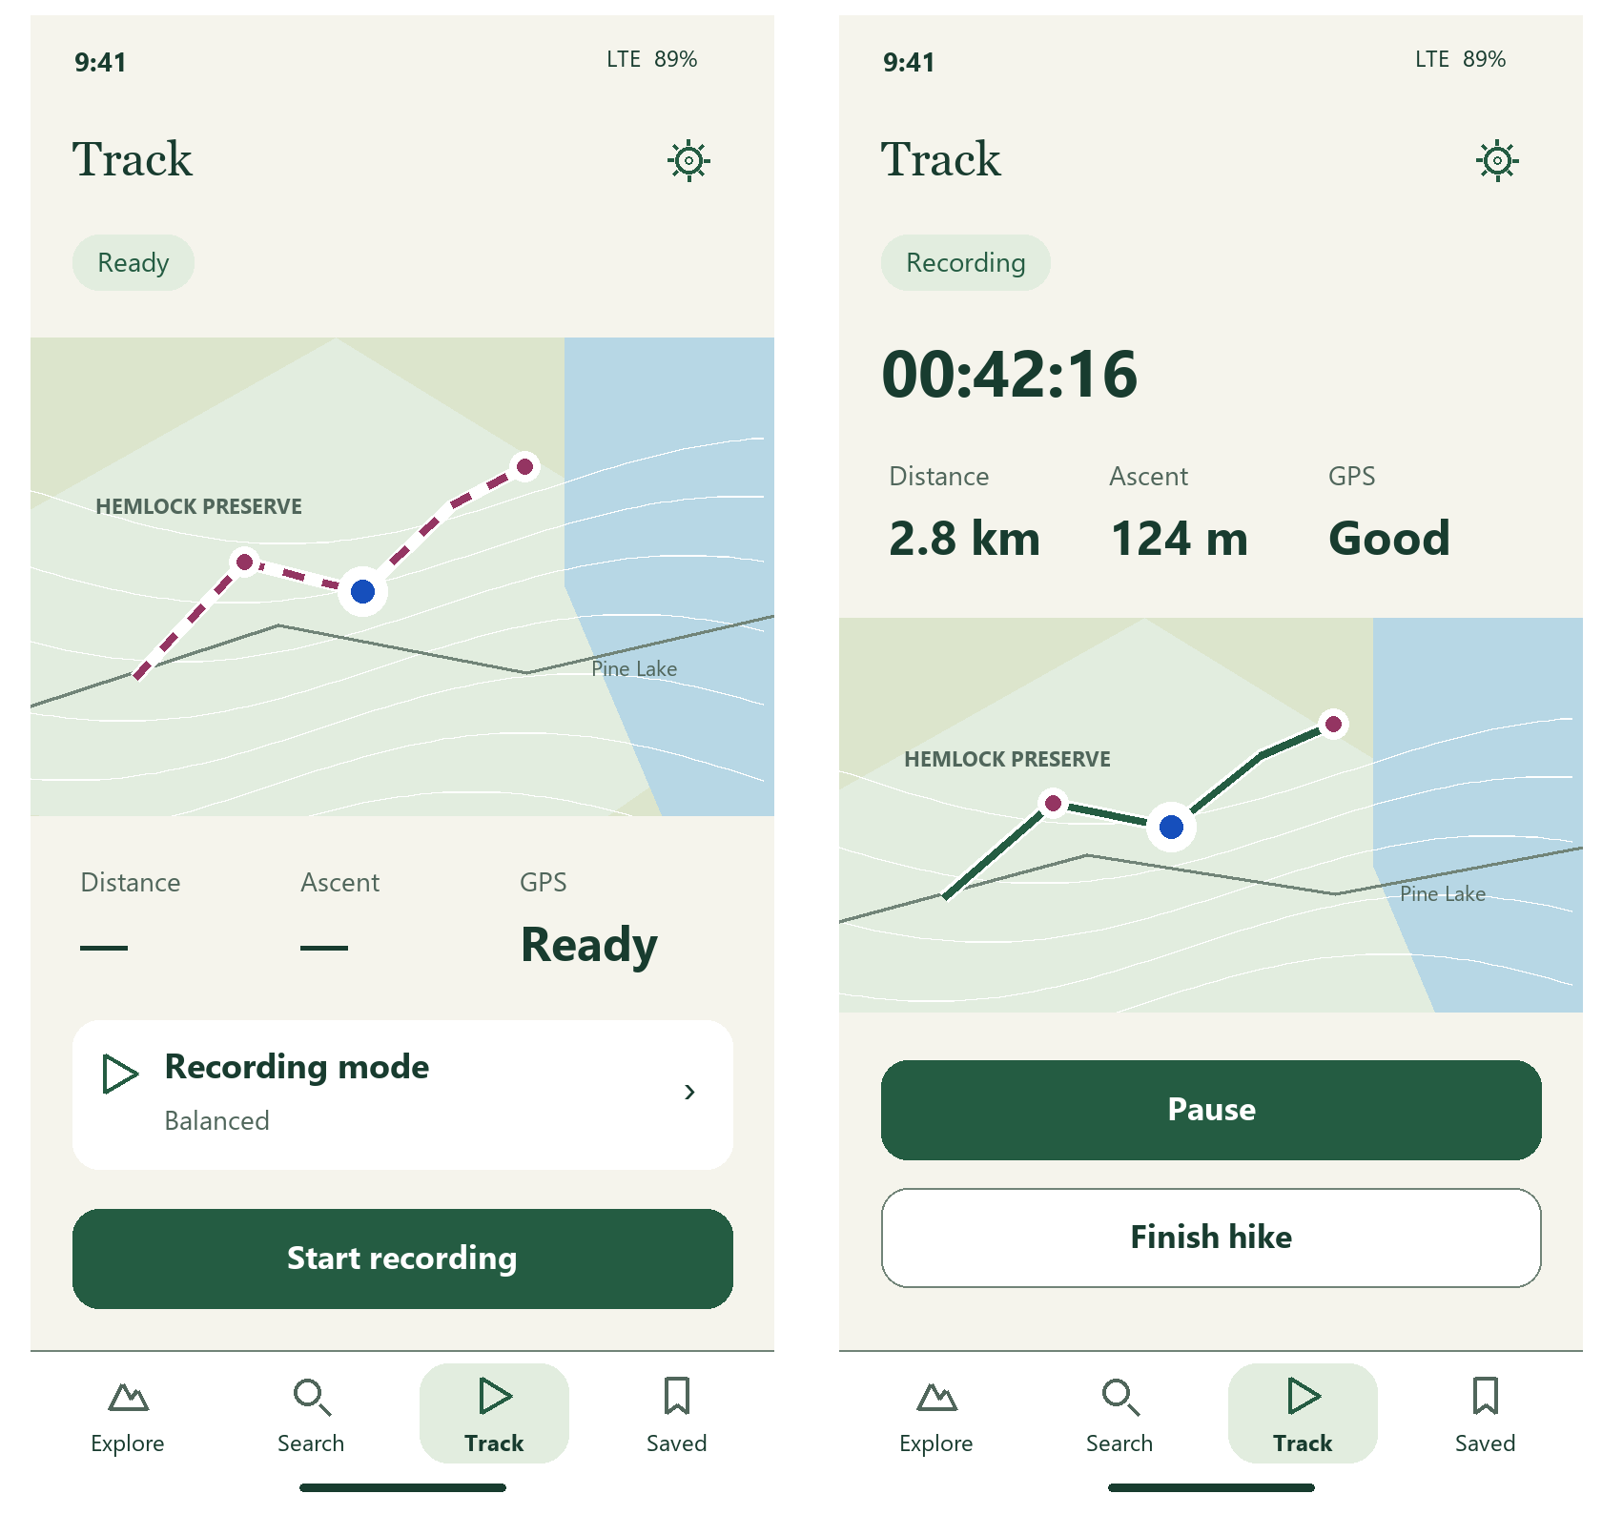
Left: ready. Right: active recording.
Offer Balanced, Endurance and High Accuracy through the mode row. Keep Pause dominant during capture and Finish hike separate. Permission and GPS quality come from real state; unknown values use an em dash with an accessible Unknown label.

Paused recording and saving
Keep the elapsed time and path stable during pause. Finishing opens an explicit save step rather than a crowded set of recorder buttons.
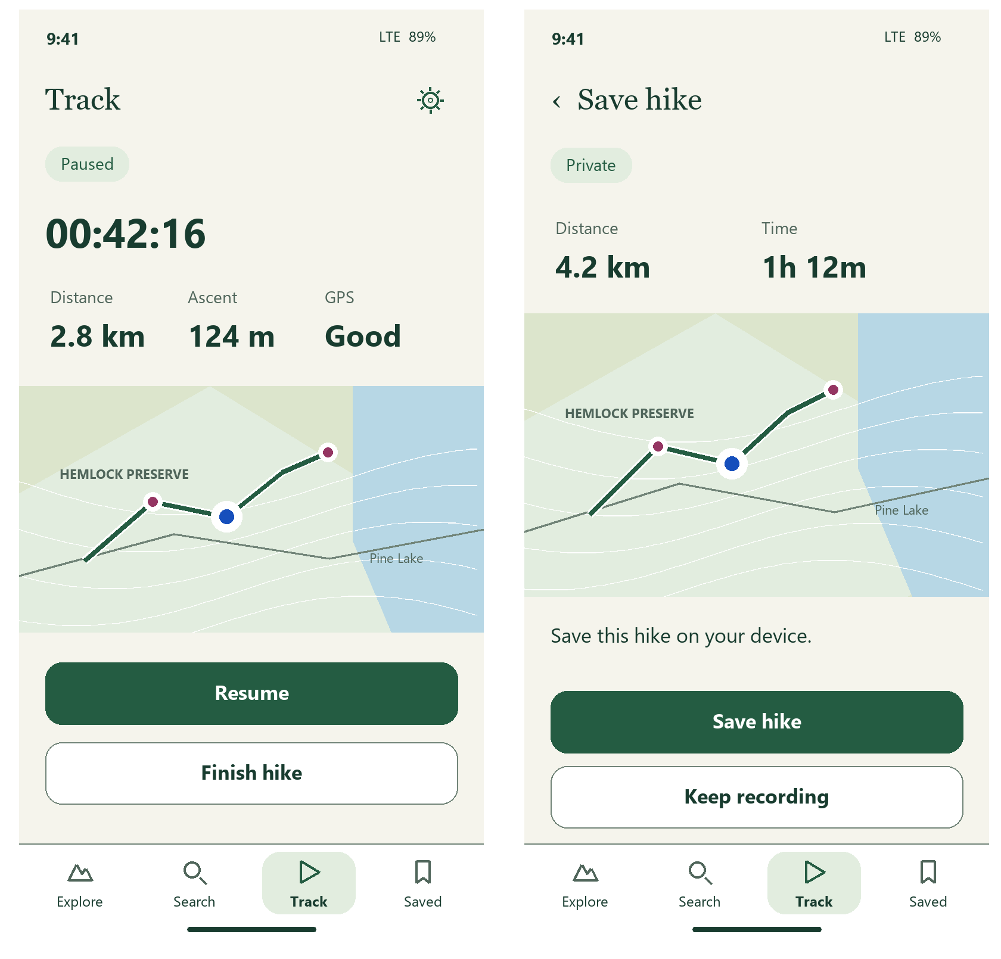
Left: paused capture. Right: finish and save.
Resume is the primary paused action. Save hike stops capture and retains the private activity. Keep recording returns to capture. Any added naming editor is a later feature; this proposal does not require one.

Recovery and location access
Recovery and permission explain the immediate choice with one sentence. Neither should replace the rest of the app with an instructional wall.
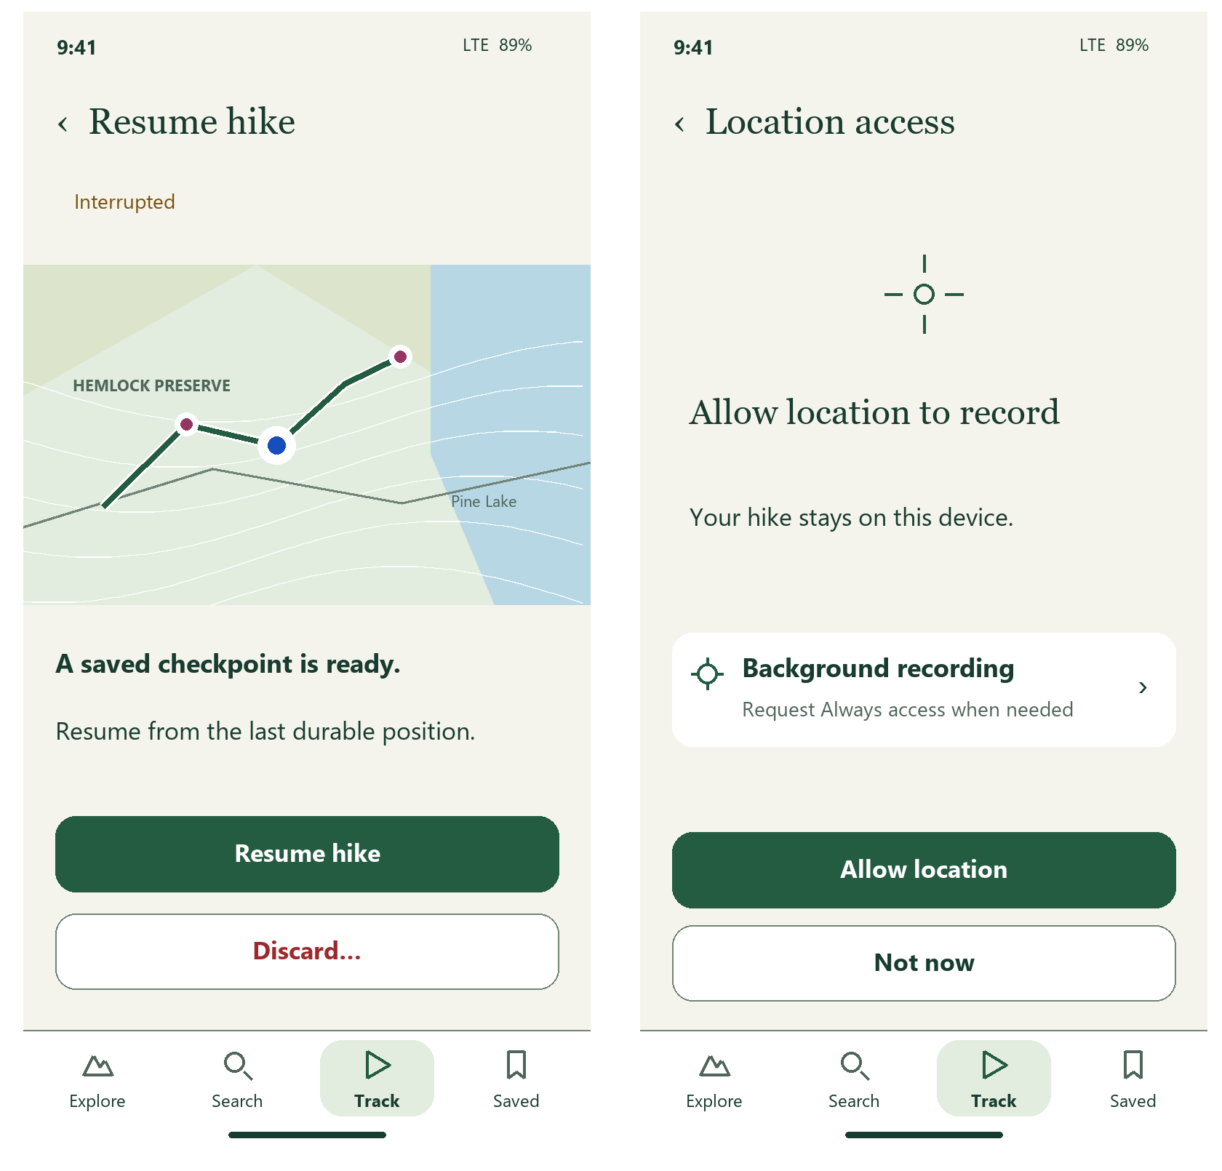
Left: interrupted hike. Right: permission preflight.
Recovery starts from the last durable checkpoint. Discard opens Cancel / Discard hike with a permanent-loss explanation. Ask for Always access only for the relevant background workflow; denied access still leaves maps and saved content usable.

Saved hikes and saved places
Use Hikes and Places as two views of the existing private library. Route previews and short metadata replace observation IDs in the main list.
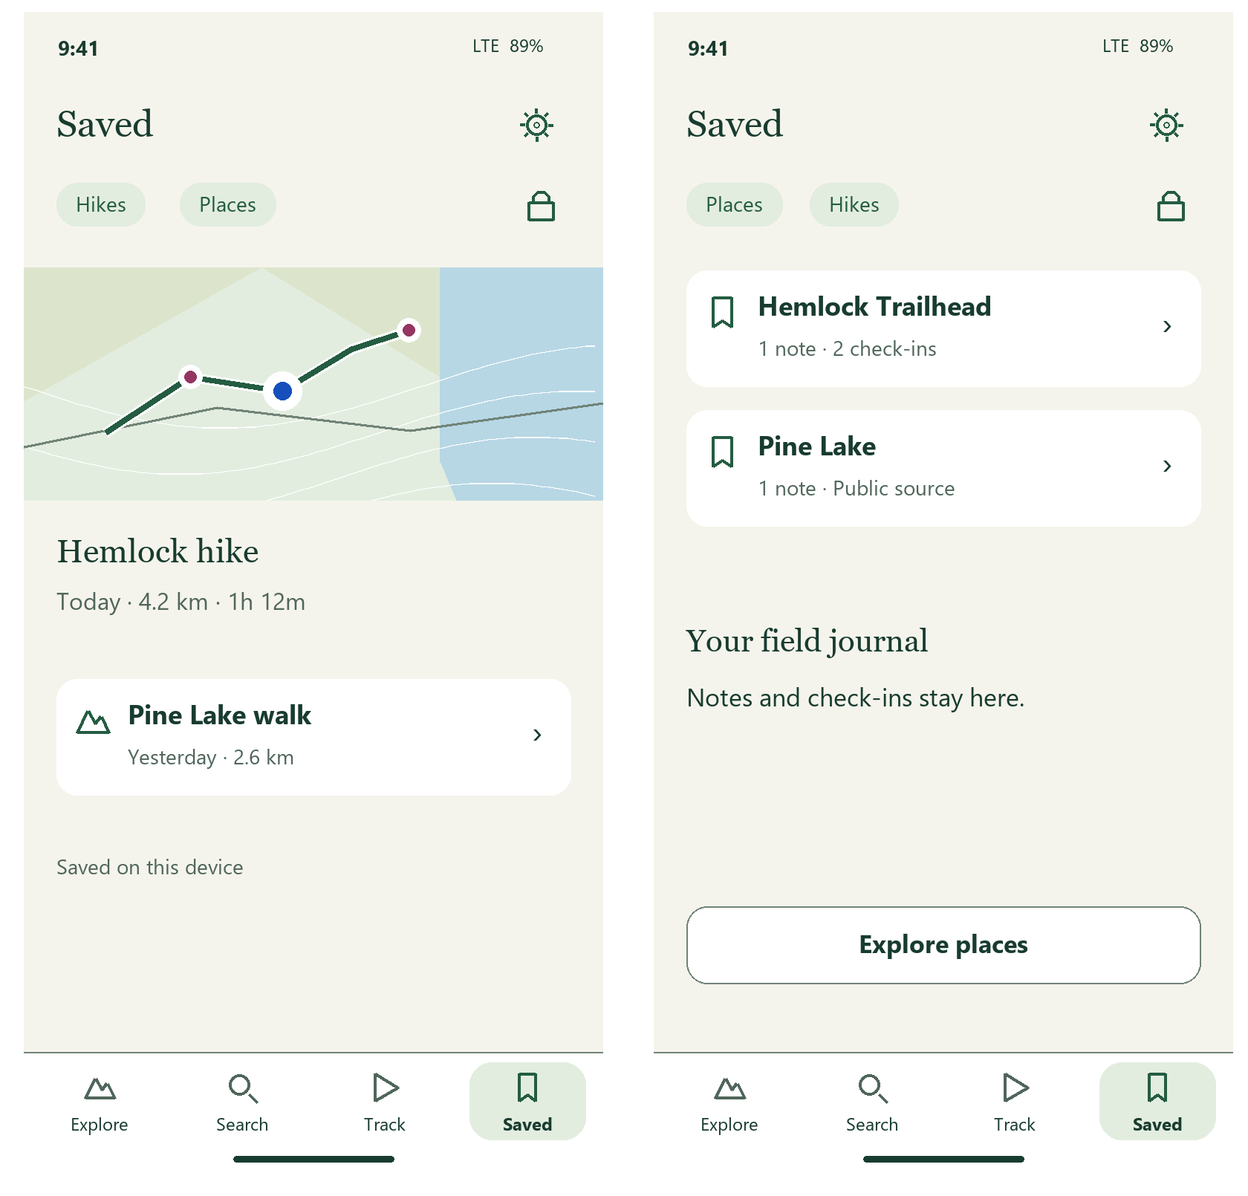
Left: recorded hikes. Right: notes and checked-in places.
Only show distance, duration and preview when derived from saved activity data. Keep technical sequence IDs in diagnostics. An empty library says No hikes yet or No places yet, with Record a hike or Explore places.

Recorded activity and missing references
Retain the recorded route when an associated dataset is hidden or removed. Planned and Recorded controls make comparison explicit.
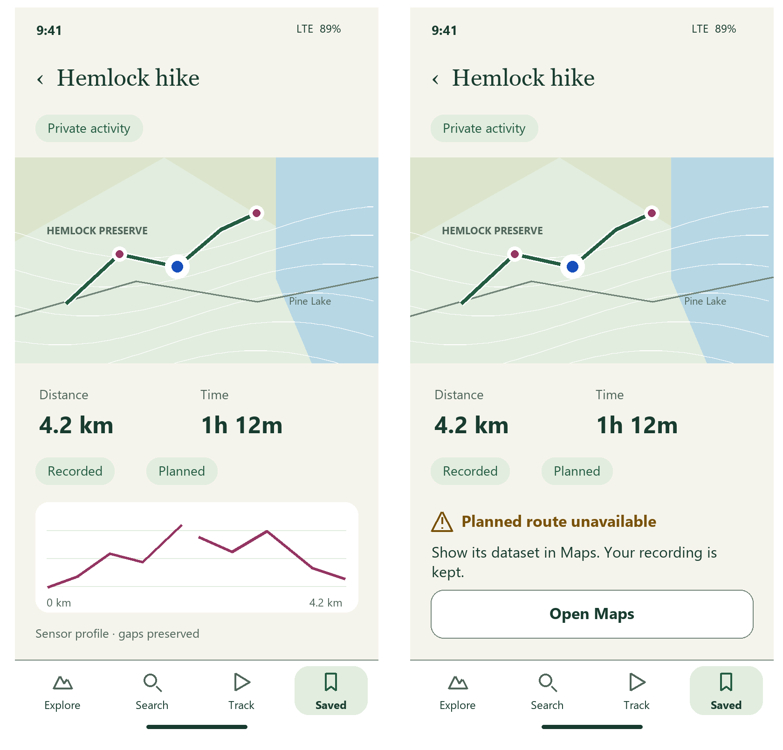
Left: recorded profile. Right: unavailable planned reference.
Preserve paused sections and missing sensor elevations as gaps. Profile selection marks the matching map sample. Open Maps restores a hidden reference; recorded paths, notes and check-ins are never removed with a reference package.

Settings and map inventory
Settings becomes a short index. Maps clearly separates bundled basemaps, installed public states and private data.
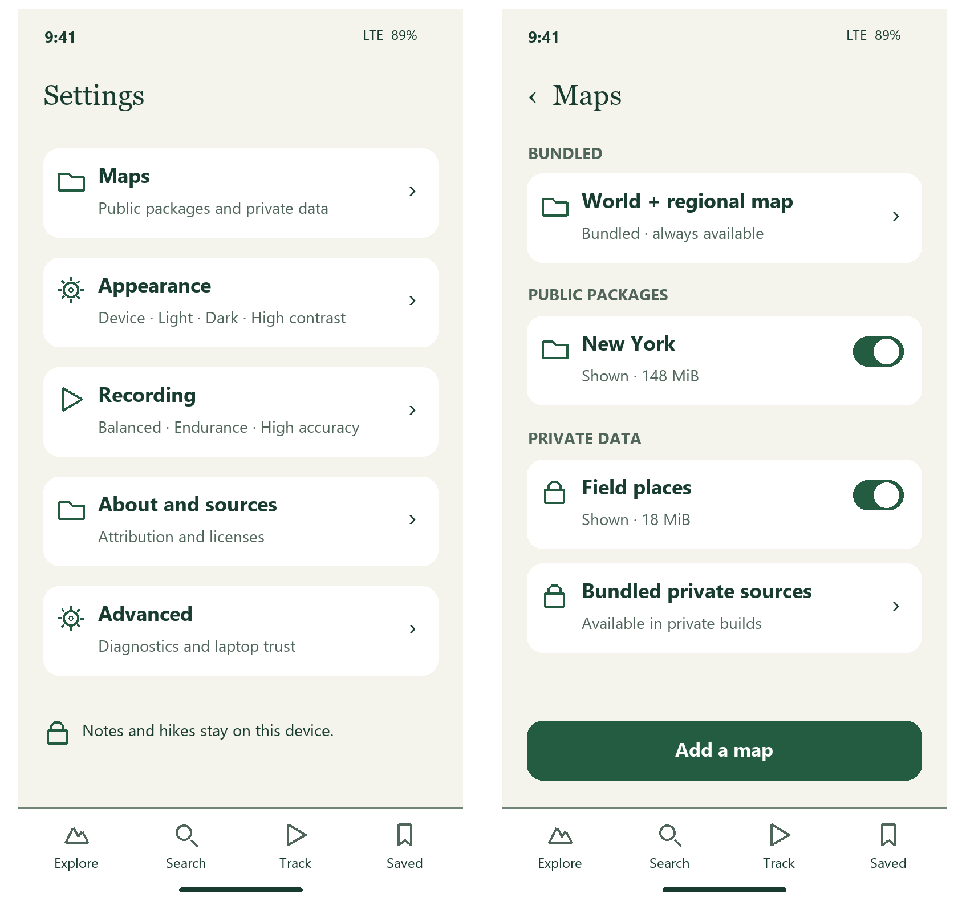
Left: Settings index. Right: complete map inventory.
Each optional package shows Shown or Hidden, origin and storage size. Bundled maps are read-only and always available. Private build sources appear only when present; empty groups state No public packages or No private datasets.

Public packages and private datasets
Keep details compact and actions predictable. Visibility is a switch; coverage, source details and removal stay separate.
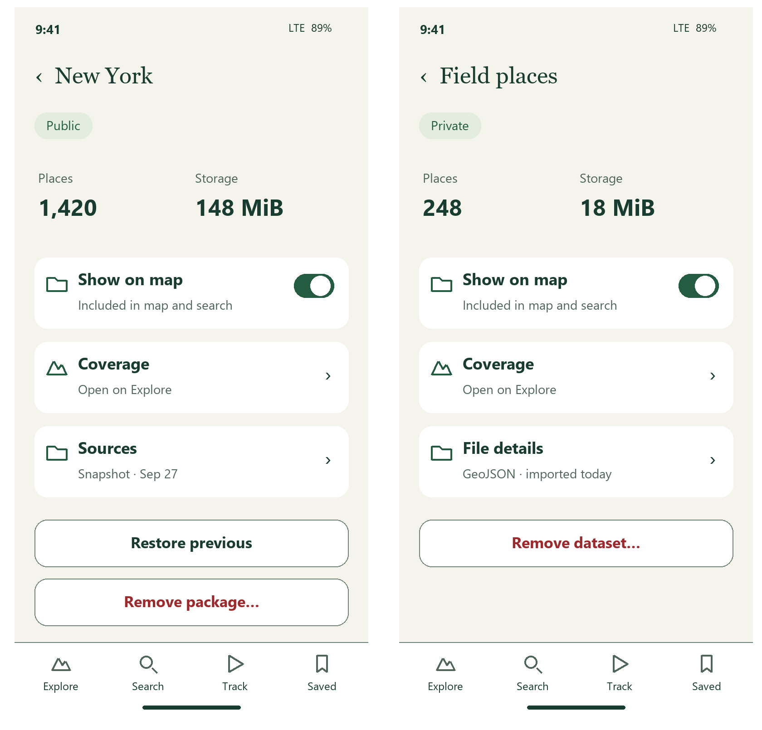
Left: installed state. Right: imported private dataset.
A public package can restore an available prior version. Remove package / dataset always confirms scope and keeps user recordings and notes. Retain dates, source notices, integrity warnings and full file limits in the detail view.

Adding maps and reviewing imports
Choose the source once, then review the file. Keep state-package installation distinct from private GeoJSON imports.
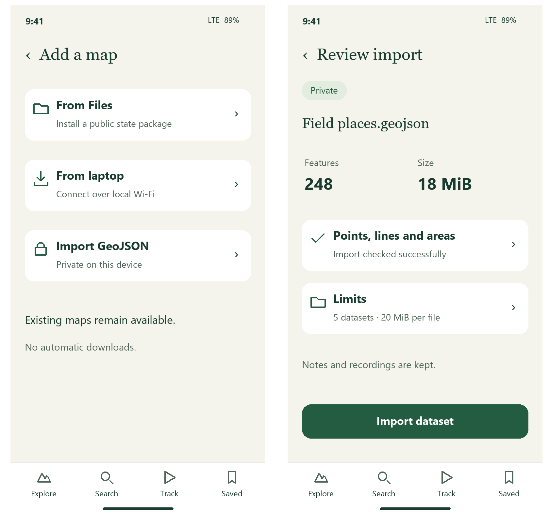
Left: Add a map. Right: valid GeoJSON review.
Review is a proposed UI step over current validation. Keep the existing five-dataset, 20 MiB and 20,000-feature per-file limits. Show rejected / partial records explicitly. A cancelled picker or failed verification leaves installed data intact.

Laptop connection and update approval
Offer scanning first, nearby discovery next and manual entry as a fallback. Approval remains a separate step.
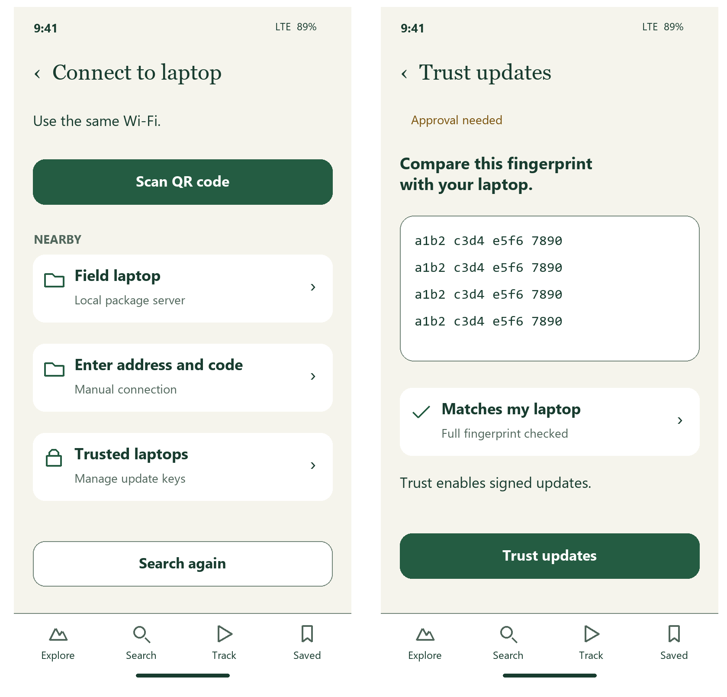
Left: laptop discovery. Right: signing-key approval.
Manual entry keeps labeled address, code and optional full fingerprint fields. Show the full fingerprint for comparison; approval requires an independently pinned key. The catalog lists install / update availability, sizes and blocked older packages. Trusted laptops remain revocable offline.

Transfers and restoring a package
Show one progress state at a time: downloading, verifying or installing. Keep the current map usable until activation completes.
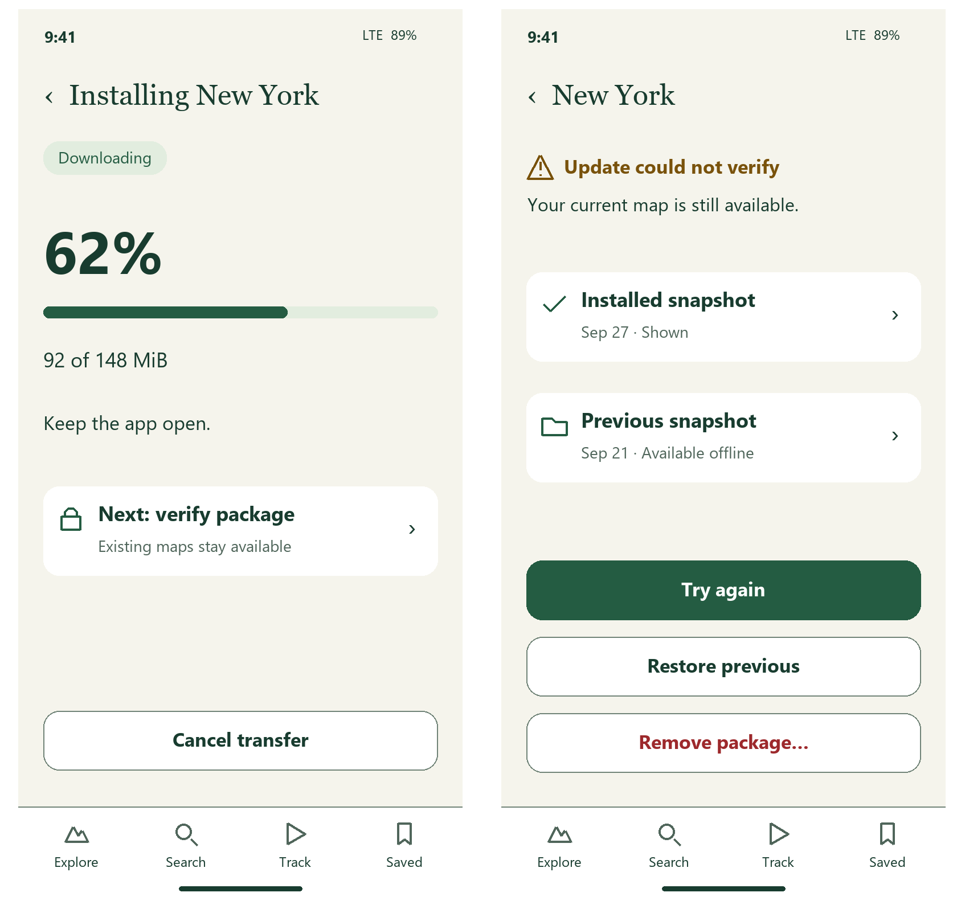
Left: transfer progress. Right: failed update with current map retained.
Cancel remains available during transfer and is disabled during atomic verification / activation when required. Rollback confirms the previous snapshot. Backgrounding disconnects the laptop and explains how to retry; incompatible or untrusted updates stay blocked.

Appearance and readable controls
Retain the existing dark and high-contrast colors. Device appearance remains the default; choices are explicit and local.
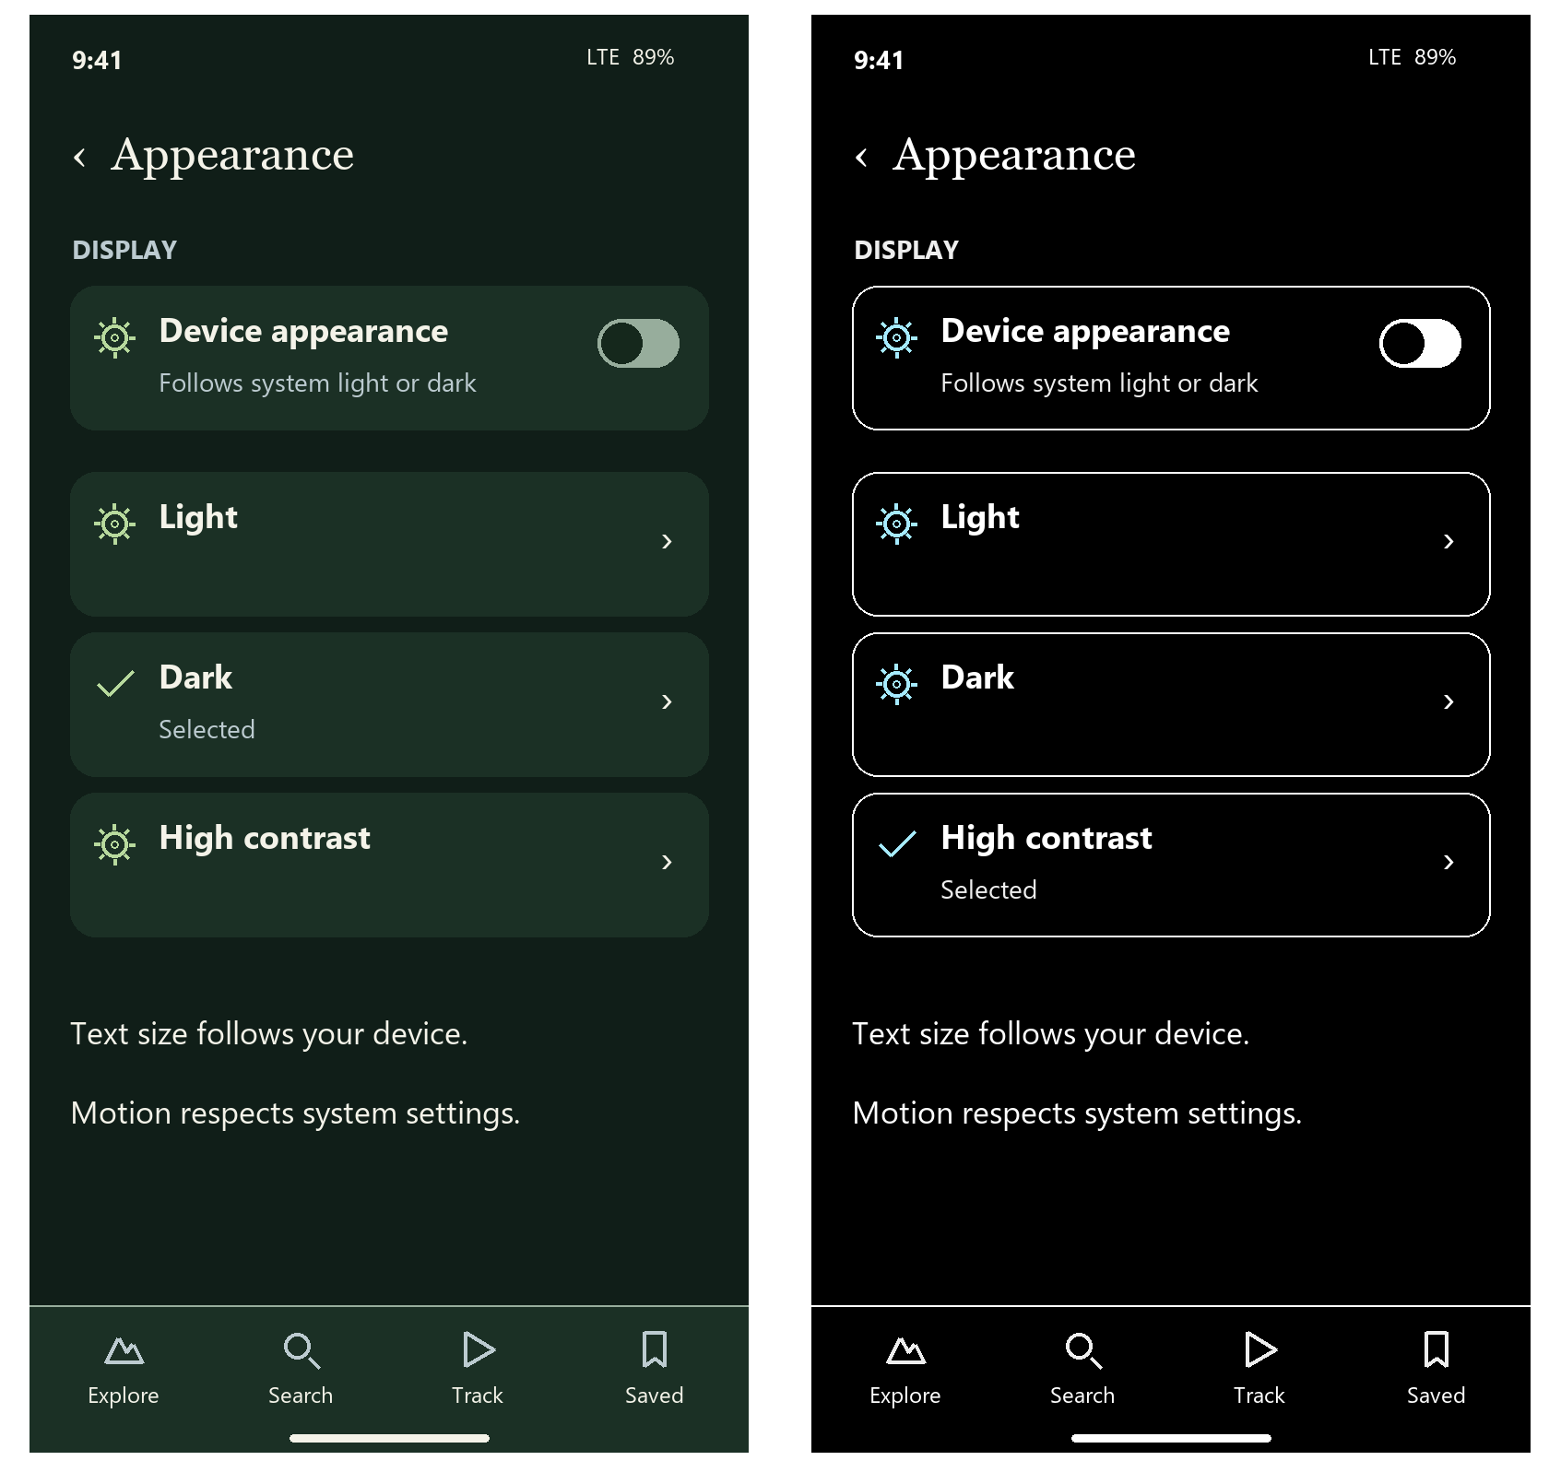
Left: dark appearance. Right: high contrast.
No muted text becomes unreadable. Use the existing focus color, visible borders and selected names. Text follows device size; controls grow and wrap at 200 percent. Reduced motion removes sheet flourish; haptics follow supported device preferences.

Advanced diagnostics and source notices
Keep technical tools and license text reachable through Settings. Main screens contain only information needed for the task.
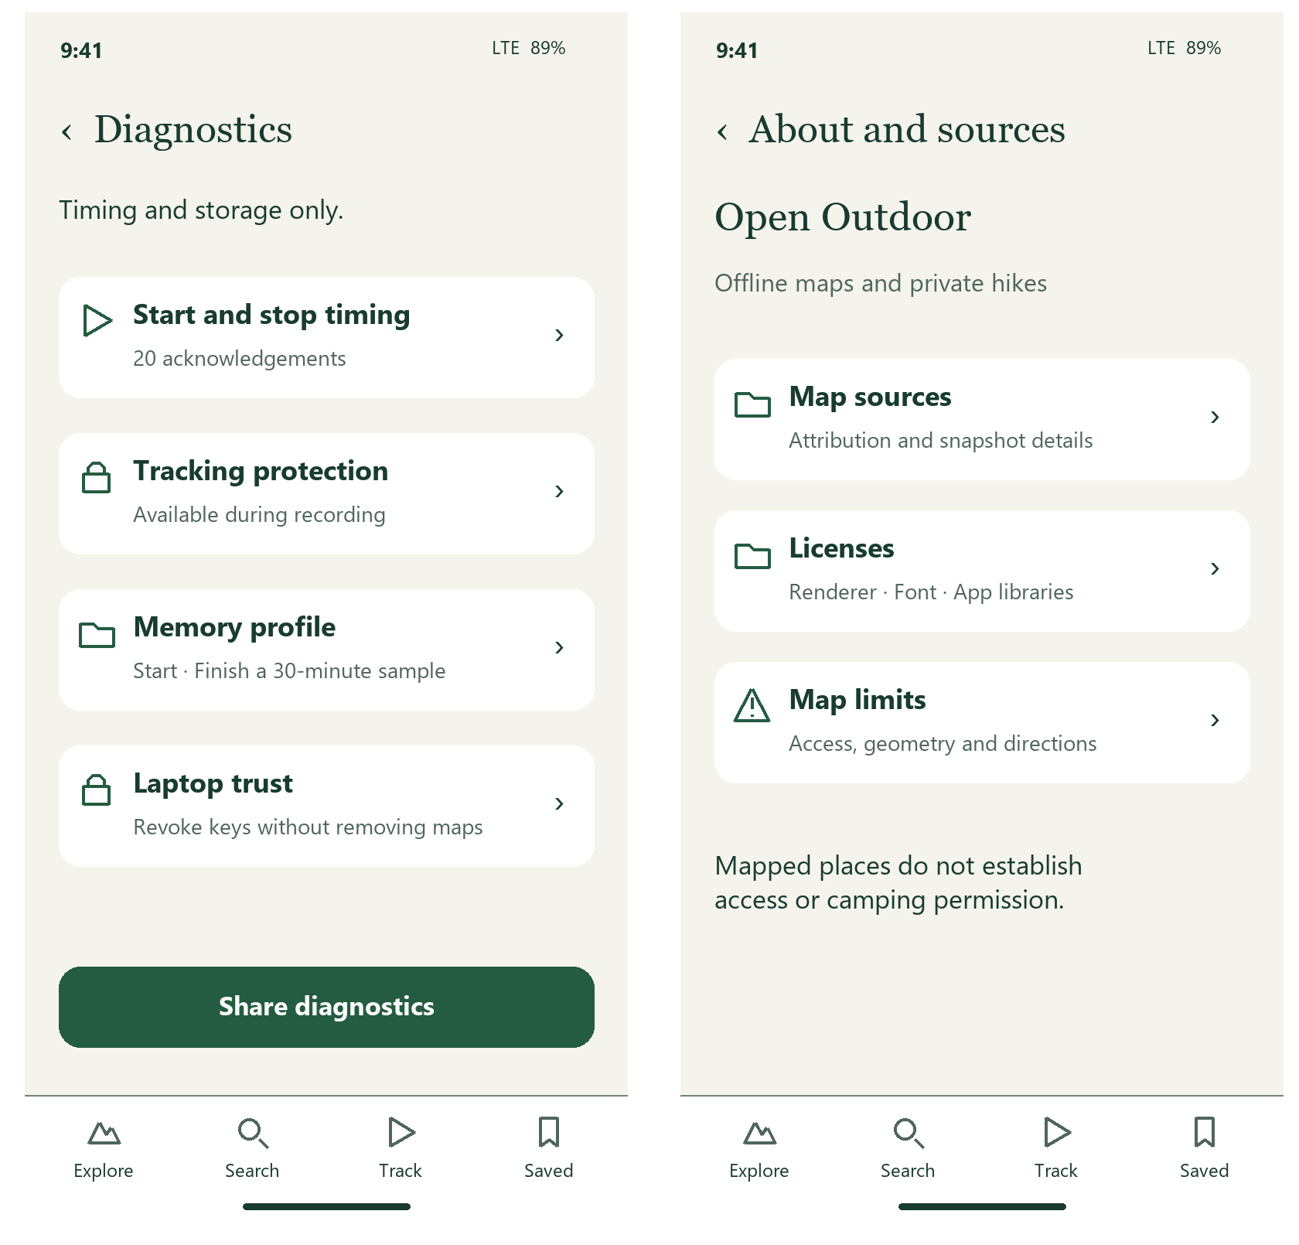
Left: advanced diagnostics. Right: About and sources.
Preserve timing, tracking protection, memory sampling and coordinate-free diagnostic sharing when available. Full source and renderer / font / library notices remain readable and selectable. Keep required map attribution on the map as well.

Empty search and startup failure
Failures name the problem and give the next available action. Technical detail expands separately; it does not replace plain language.
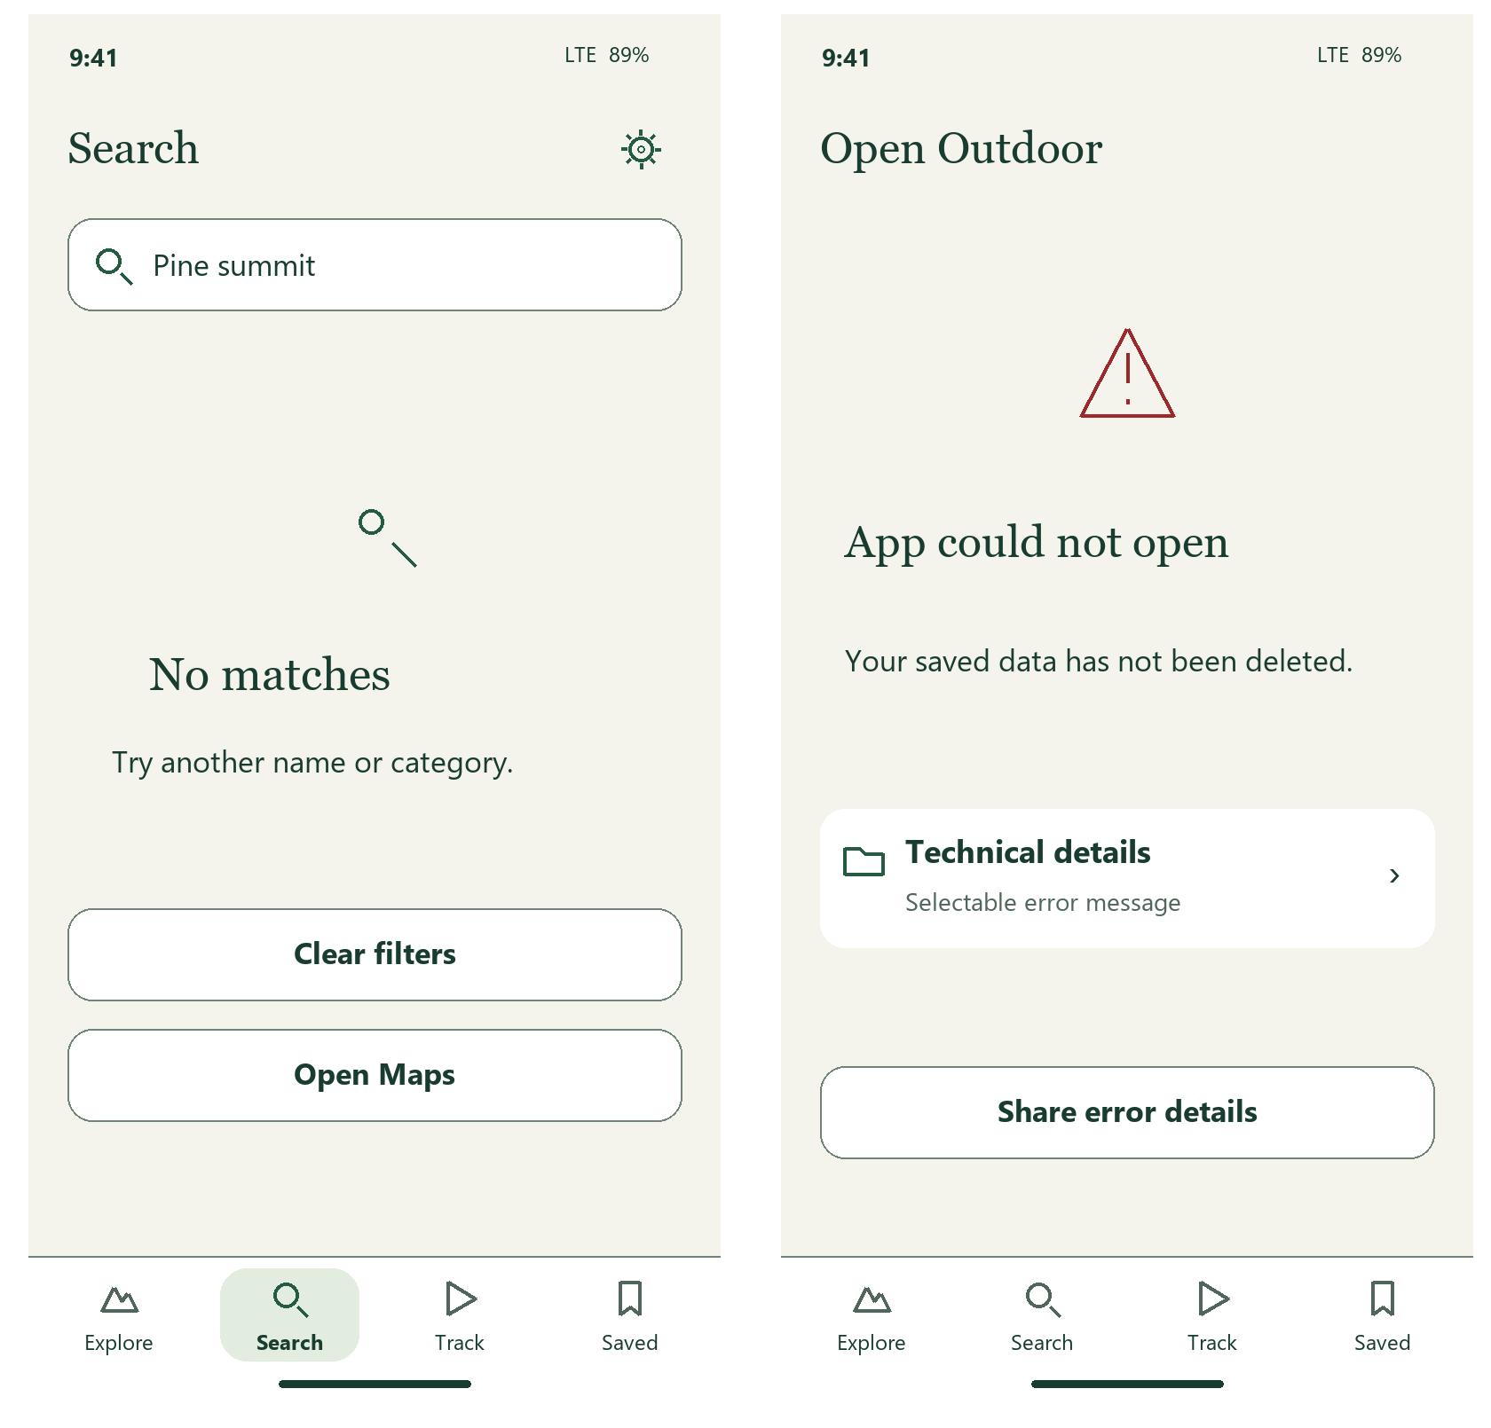
Left: no search matches. Right: startup error.
Map load failures retain list search when usable. Unsupported native capabilities explain how to obtain a compatible build. Do not promise Retry or restoration unless the implementation can perform it; startup sharing can use the existing selectable error text.

Field clarity and all state treatments
Use concise, contextual messages. Ordinary offline use needs no repeated warning. Safety, data loss and source uncertainty stay explicit.
State | Visible copy | Placement | Next step
Empty | No hikes yet | Saved | Record a hike
Loading | Loading maps… | Current surface | Keep prior content
Error | Could not finish | Affected action | Retry when supported
Stale | Source may be outdated | Place detail | Source details
Degraded GPS | GPS weak | Recording status | Keep gaps visible
Offline | Offline | Connection task | Use installed maps
Denied permission | Location is off | Track | Open device settings
Expired provisioning | App needs renewal | Launch / system | Explain reinstall or renewal
Activation | Installing map… | Maps | Disable conflicting actions
Rollback | Previous map restored | Package detail | Show snapshot date
Partial import | Some records skipped | Import review | Inspect counts / rejected parts
Insufficient space | More space needed | Install / import | Show required space
Source conflict | Sources disagree | Place detail | Compare source records
Private extension missing | Private data unavailable | Maps | Show compatible-build action
Rights excluded | Not included | Source inventory | Explain the source restriction
Private origin | Private | Item origin | Keep a lock and readable label
Closure | Closure reported | Place preview / detail | Show source and date
Unknown access | Access unknown | Place preview / detail | Do not imply permission
Recording | Recording | Track / return control | Pause
Paused | Paused | Track / return control | Resume
Recoverable | Hike interrupted | Track | Resume or confirm discard
Low battery | Battery low | Active recording | Open recording mode
Checkpoint error | Save checkpoint failed | Track | Explain durability risk
Completion | Hike saved | Saved / confirmation | View hike
Announce state changes once. Keep changing byte counters readable on demand. A concise warning can expand to its cause and recovery details; never shorten away a closure, permanence or trust condition.

Adaptive layout and accessible behavior
The phone remains the primary design. Wide screens keep the same content and task order, with a map and adjacent detail column. The browser is a reference surface, not a new consumer product.
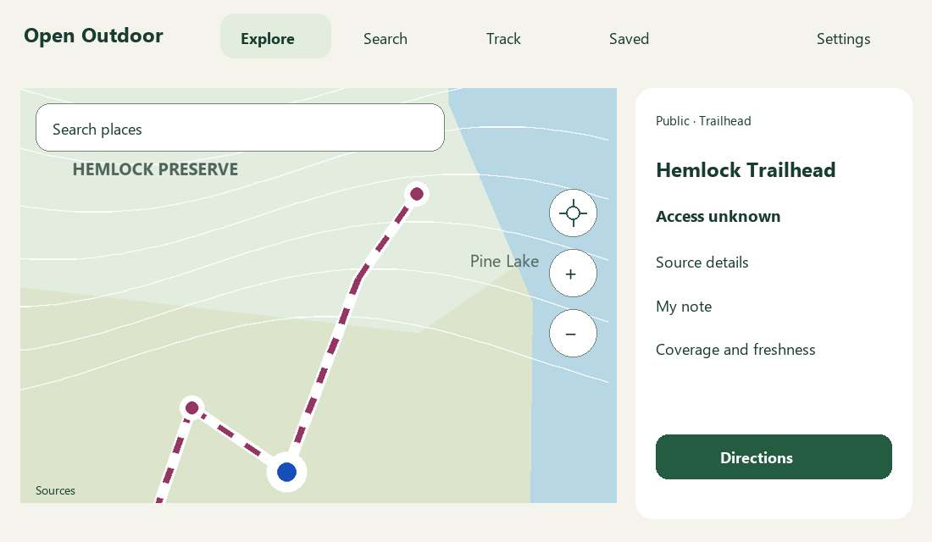
Proposed wide-screen map and detail arrangement. Illustrative geometry and place text.

Reading and interaction
At larger text sizes, prioritize the current action and let the page scroll. Never pin a metric or button over content. Preserve all four labeled tabs; expand their row rather than truncate names. Keep focus order header → content → actions → navigation, with a keyboard skip link in browser references.
Every icon-only action has a spoken name and a 52 point target. Sheets announce their title and contain focus until closed. No gesture is the sole path. Charts expose a sample readout, units and a text summary; maps retain list access, legend and source details.
Use at least 4.5:1 for text and 3:1 for meaningful control / map marks, tested in each existing palette. Evaluate long names, 200 percent text, screen-reader use and outdoor readability on the native build before release.

Concise copy and design handoff
Use task names and familiar verbs. Keep explanatory text at the moment of uncertainty or risk, with detail available on request.
Current label | Proposed label | Preserved meaning
Explore outdoors | Explore | Map discovery
Find a place | Search | Local query
Your hikes | Saved | Places and recordings
Start hike capture | Start recording | Start sensors and capture
Pause hike capture | Pause | Pause the active capture
Finish and save recording | Finish hike → Save hike | Deliberate stop and save
Check in now and save note | Check in | Timestamp plus current note
Save note without checking in | Save note | Note only
Show coverage of a dataset | Coverage | Fit its actual bounds
Restore previous state version | Restore previous | Offline rollback
Map renderer licenses | Licenses | Complete notices remain available

Coverage checklist
The gallery contains 34 proposed phone states plus a wide-screen composition. The flow inventory and state catalog cover the remaining variants: map tools / legend, all categories, long / empty results, recording modes, background access, discard and remove confirmations, library empty states, import errors / reset, laptop manual entry / catalog / revoke, units / profile gaps, source limits and unavailable capabilities.
Use a single confirmation pattern: action name, one consequence sentence, Cancel and the explicit destructive verb. Removal keeps notes and recordings; discarding recovery permanently loses that unsaved hike. The full source fingerprint and required trust explanation remain in approval views.

Implementation boundary
This is a document-only proposal. New sheet layouts, review steps and Settings groupings require later implementation. Existing capture, catalog verification, recovery, privacy and source-rights behavior remain constraints. Do not add accounts, ratings, cloud sync, social feeds or unverified access claims to fill space.
Reference reviewed: the prior Word guide; all six docs/design app-current captures; current App, OutdoorMap, HikeDetails, HikeCaptureControls, MapSettings, LaptopPackages and startup error views; shared design-system palettes and field states. Source paths are repository-relative. Screenshots are browser examples; proposed concepts are project-authored and use synthetic data.

